Progress Report – Computer Graphics

Jose Marquez

Estimated Total Hours

I estimate that I spent approximately 14 hours completing this assignment in a period of 7 days:
- Part 1 (Phong-lit cube): 4 hours

- Part 2 (Adding and lighting solids): 5 hours
- Part 3 (Interactive scenes with multiple materials and light models): 5 hours

Part 1 Results – Phong Lighting on gold cube

For part 1, I implemented Phong illumination on a single cube using my own vertex and fragment shaders (by choice). The cube uses a solid gold material defined by ambient, diffuse, specular, and shininess values. The vertex shader computes the world-space position and transforms the normal with a normal matrix, while the fragment shader combines:

- ambient term: u_AmbientLight * u_MaterialAmbient
- diffuse term: based on max(dot(N, L), 0.0)
- pecular term: using reflect() and pow(dot(R, V), u_Shininess)
The result is a cube where one side is brightly lit with a specular highlight, and the opposite side is dark. This is because it is in shadow, normal for a shading with a point of light

Part 2 Results – Phong Lighting on Platonic Solids
For part 2, I extended the same Phong lighting model to the Platonic solids I used in the previous assignment, plus a sphere:
- Cube
- Tetrahedron
- Octahedron
- Icosahedron
- Dodecahedron
- Sphere
I have coded this part so each solid is defined by its own positions and indices arrays. I wrote a buildSolidData(name) function that:
- Expands the indexed triangles into a flat vertex array.
- Computes a flat face normal for each triangle using the cross product of edge vectors
- Produces a parallel position and normal arrays for the WebGL environment
The same shaders from Part 1 are then used to shade all of these new solids. I have set the environment up so I can switch between solids at runtime using my keyboard. Each of these solids shows proper shading and specular highlights, in my opinion.

Part 3 – Interactive Scene with Materials and Lighting Models
For Part 3, I built an interactive scene that:
- Renders one of the solids at a time with continuous rotation about the Y-axis.
- Animates the light source along a circular path around the object so the highlight moves over the surface.
- Supports multiple materials and lighting modes, which can be switched via keyboard.

Current interactions:
- Shape selection (Platonic solids + sphere):
  - 1 = cube
  - 2 = tetrahedron
  - 3 = octahedron
  - 4 = icosahedron
  - 5 = dodecahedron
  - 6 = sphere

- Material selection:
  - M or m cycles through the material array (e.g., gold and a jade-like material).

- Lighting model selection:
  - L or l cycles u_LightingMode between three modes inside the fragment shader:
    - ambient + diffuse
    - ambient + diffuse + specular (full Phong)
    - a mixed mode (ambient plus a scaled combination of diffuse and specular)

The scene uses a perspective projection and a lookAt camera aimed at the origin, so I can clearly see the rotation and the effect of the moving light on different geometries.
Also, this scene was a bit tricky, and I watched a couple of videos on how to implement the buttons to use my keyboard and surf between solids, materials, and lighting.

Experience and Problems Encountered
Overall, this assignment helped me understand lighting math and how to structure a WebGL program with reusable shaders.
The Keyboard interactions that I added came from an idea that I had, talking to my dad about this assignment, and it was tricky, but I am very proud that I was able to implement.
Some issues I ran into:
- Shader compilation bugs:
I initially had type mismatches all around my code, in the vertex shaders, and a uniform name mismatch as well. These were causing the program to fail at runtime until I was able to carefully check my shaders line by line.
- Extra Brace in the Fragment Shader:
I had a stray } at the end of the fragment shader string that was causing a compile error. I am a little embarrassed to not have been able to catch that sooner, but in the end, I figured it out.
- Normals facing facing the wrong way:
This one was very tricky when I extended the lighting to a Platonic solid; some faces appeared unusually dark. I was able to figure out that this was due to inconsistent index winding, which made the normals point inward instead of outward. Again, I am a little embarrassed to admit this happened to me, but it made me realize how important consistent winding and normal direction are for correct lighting.
- Solids not showing on the canvas:
At one point, I only saw my black canvas on the screen. The issue was that I was using a solid name with the wrong capitalization (again silly error), which caused my build solid data function to fail because it could not find a key.

Added extensions
I decided to add a sphere using latitude/longitude subdivision (Dad’s advice), as well as adding an orbiting light source.
I’ve added multiple materials, which was very fun to do, and play around with the color of these materials, which made me want to add multiple lighting models too.

Sources Used

- Course lectures and example code
- Online references and videos
- Web documentation for references on the WebGL API.
Snapshots:
- Part 1 – Phong-Lit gold cube

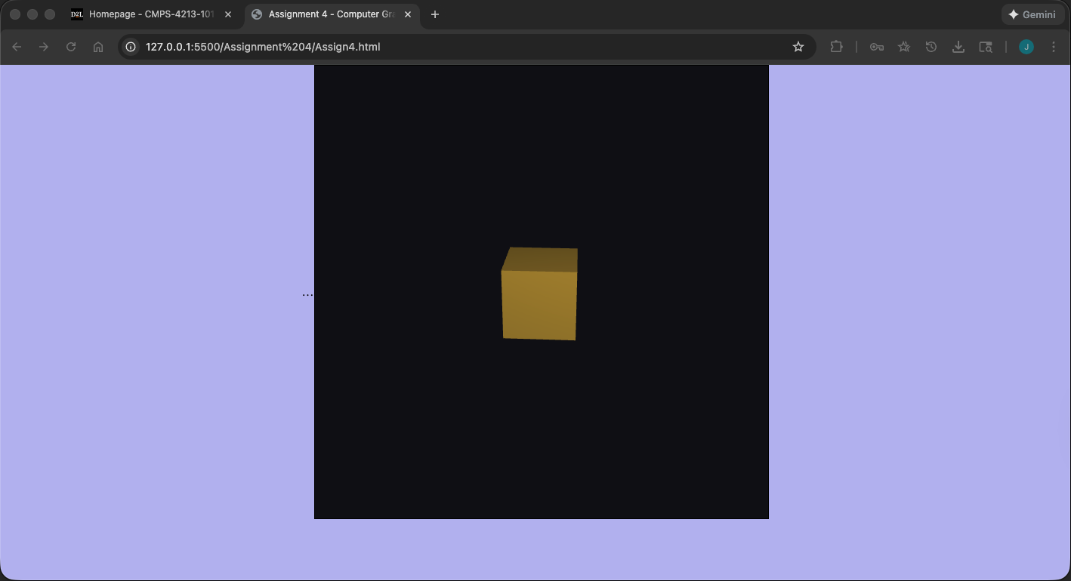

Part 2 – Added Lighting to different solids

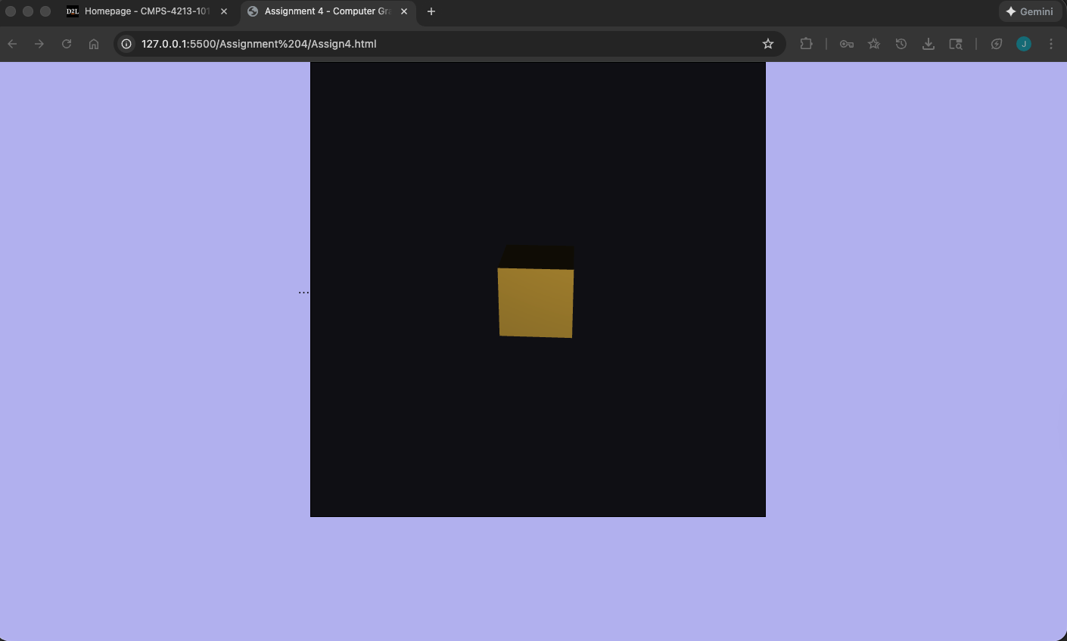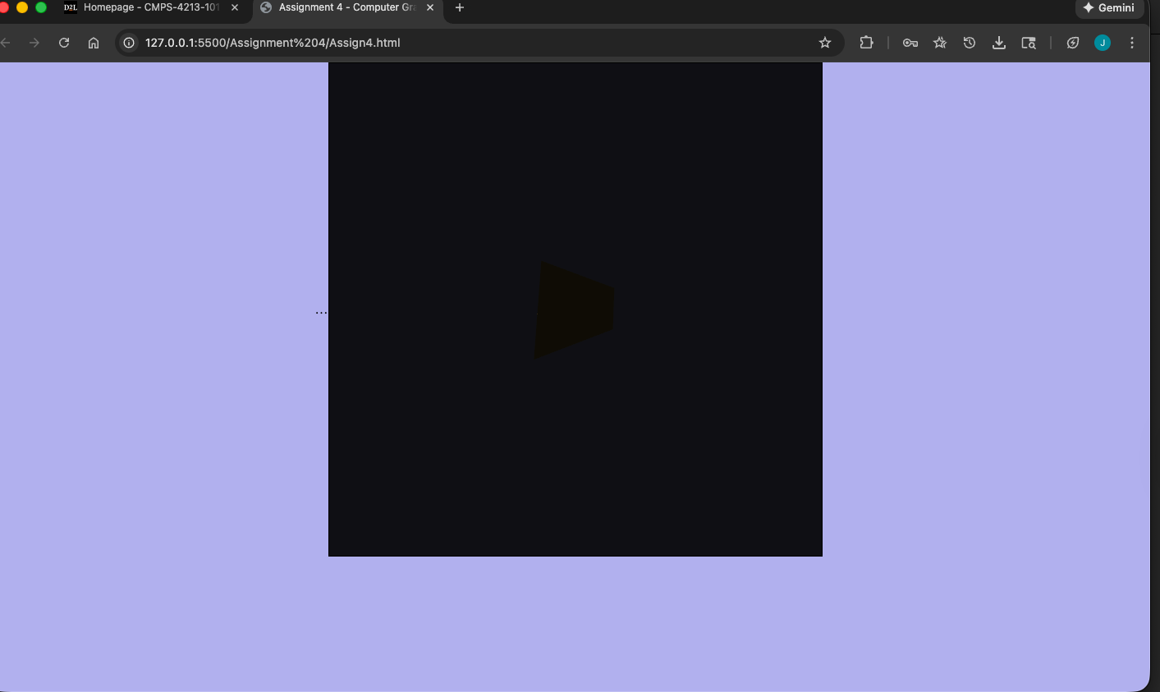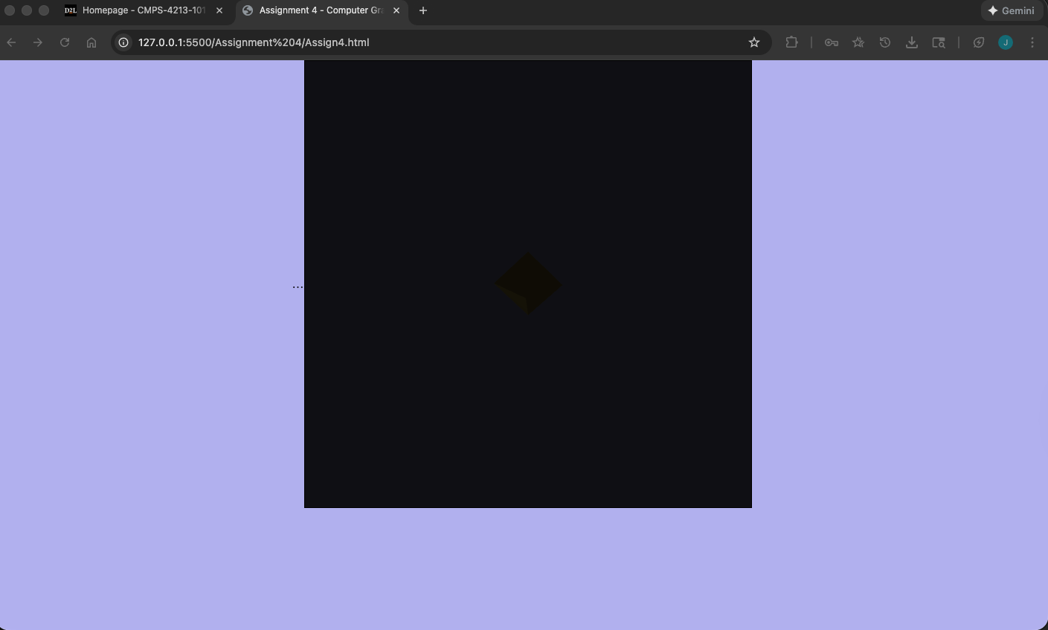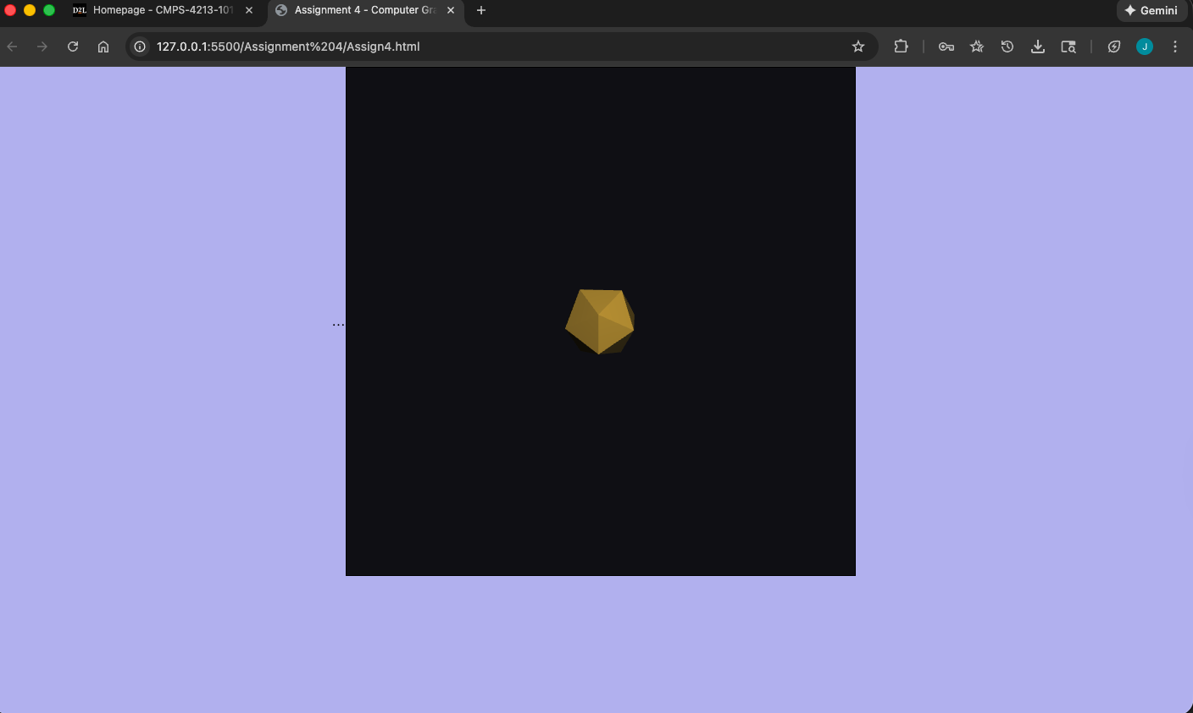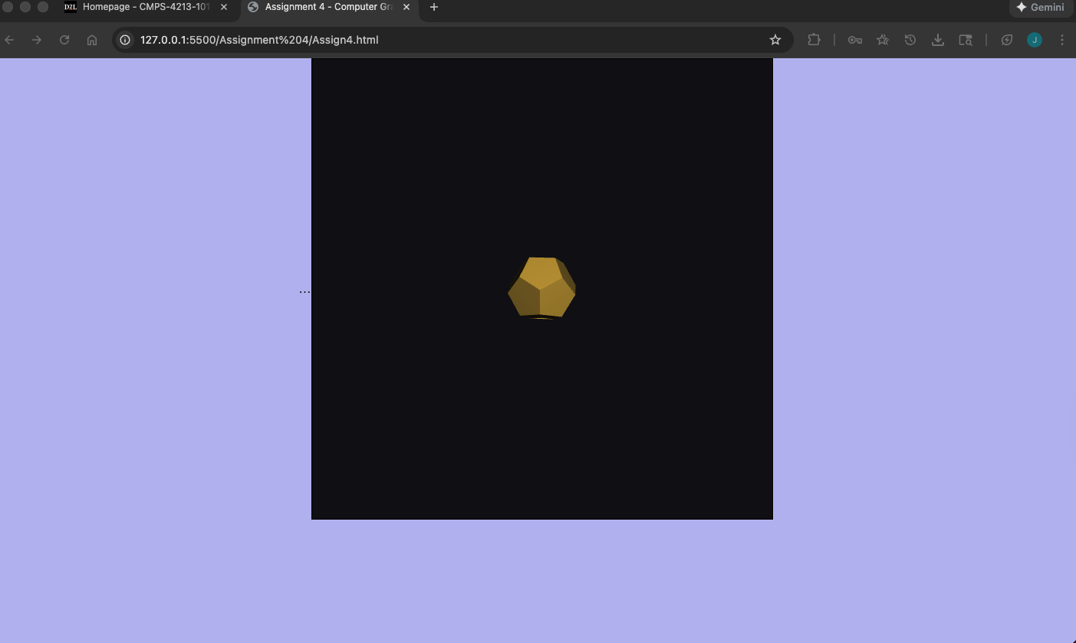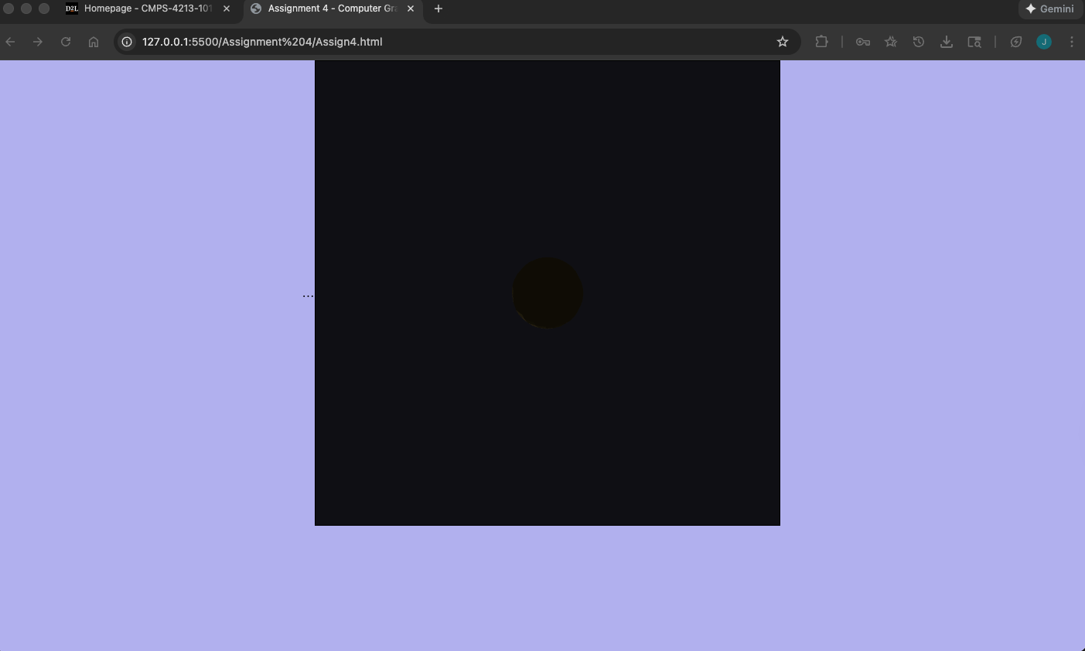

Part 3 – Interactive scene
